## **HP MSM Networking Wireless Products**

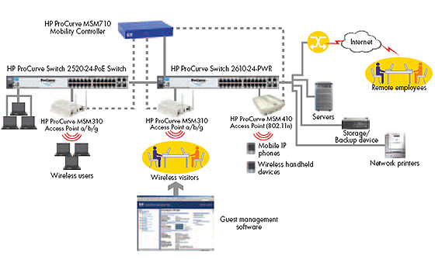

**HP MSM-802.11a/b/g Access Point Series**

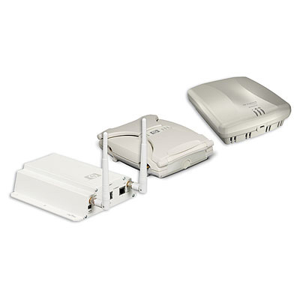

**Product overview**

HP offers intelligent single, dual and tri radio Access Points designed to provide reliable, easy-to-use wireless connectivity across the network. HP also offers integrated RF Security Sensors in some of their APs. All the HP MSM Access Points and integrated RF Security Sensors operating are managed by any of the HP MSM Controllers and the HP RF Manager for the RF Security Sensors. All the HP MSM Access Points can also work in autonomous mode. The HP MSM Access Points require a single Power over Ethernet (PoE) cable drop and are IEEE802.3af compliant or can be powered directly via a power adaptor. HP has a full range of both indoor and outdoor MSM Access Points.

* Single, dual and tri radio
* Intelligent traffic forwarding, Built-in security
* Self-healing, Advanced mesh capabilities
* Client Access
* Indoor and Outdoor enclosures

**HP MSM Controller Series**

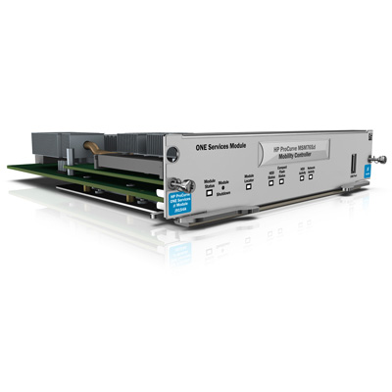

**Product overview**

Working in unison with HP MSM access points, the HP MSM Controller Series delivers high-performance networking solutions. The enhanced architecture scales to 802.11n without requiring controller replacement. Robust identity- and roles-based user account profiles, as well as Virtual Service Communities (VSCs) with independently configurable Quality of Service (QoS), authentication, encryption, and VLAN support, deliver intelligence to the network edge. Scalable from small to larger deployments, the MSM wireless controllers support a fast-roaming capability. Wireless security is comprehensive with support for internal and external authentication, authorization, and accounting (AAA) servers, built-in stateful firewall, per-user VLAN mapping, and authentication.

* Ease of use, scalability, and redundancy
* Enhanced architecture for flexible network design
* IEEE 802.11a/b/g/n AP and access device support
* Comprehensive WLAN security
* Appliance and blade form factors

